**Tatyana Vlaskin**

**Assignment 1**

**Full report: Understanding, Design(were submitted before)**

**Testing and Reflection – new sections**

**Understanding:**

We need to design an array that will store live and dead cells

Specify initial configuration of the world

Ask the user if they want to move on to the next generation

If they say yes, we need to update the world using the following rules:

1. We need to look at the neighbors around each cell. Cell is surrounded by 8 neighbors.
2. We need to determine what to do with the cells at the edges because they do not have 8 neighbors.
3. We need to count live cells about each live cell and determine whether the cell will die, move on to the next generation or a neighbor is born.
4. Alive cell dies of overcrowding if it has >3 of living neighbors. We should verify that any living cell with > 3 neighbors dies.
5. Alive cell dies of loneliness if it has <2 of living neighbors. We should verify that any single living cell or any pair of living cells will die during the next iteration
6. An empty cell becomes alive if it has exactly 3 living neighbors.
7. All other worlds remain unchanged
8. A cell dying for whatever reason may help cause birth, but a newborn cell cannot resurrect a cell that is dying, nor will a cell’s death prevent the death of another.

Following these rules, the world can fade away completely(from overcrowding or from becoming to spars or the word can settle into a stable configuration that remains unchanged thereafter or enters in an oscillating phase in which they repeat an endless cycle.

I found these patterns online: http://www.math.cornell.edu/~lipa/mec/lesson6.html

Some possible **triomino patterns** (and their evolution) and outcome: 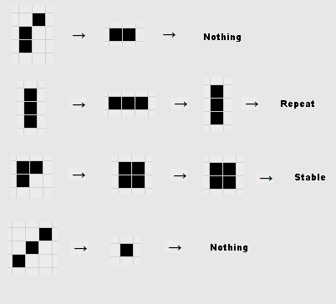

Some tetromino patterns

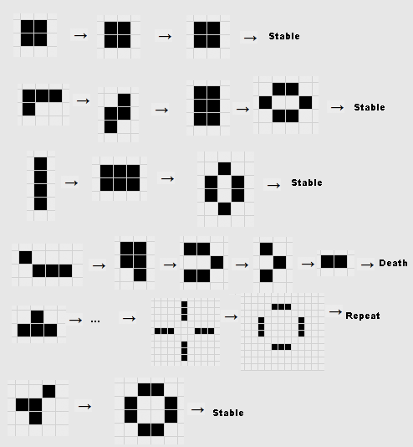

Some example still lifes:

Square : http://www.math.cornell.edu/%7Elipa/mec/sq.png

Boat : 

Loaf : 

Ship : 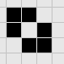

The following pattern is called a "glider."The pattern repeats every 4 generations, but translated up and to the left one square. A glider will keep on moving forever across the plane.

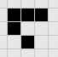

Another pattern similar to the glider is called the "lightweight space ship." It too slowly and steadily moves across the grid.

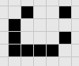

Early on (without the use of computers), Conway found that the F-pentomino (or R-pentomino) did not evolve into a stable pattern after a few iterations. In fact, it doesn't stabilize until generation 1103.

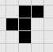

The F-pentomino stabilizes (meaning future iterations are easy to predict) after 1,103 iterations. The class of patterns which start off small but take a very long time to become periodic and predictable are called Methuselahs. The students should use the computer programs to view the evolution of this pattern and see how/where it becomes stable. The "acorn" is another example of a Methuselah that becomes predictable only after 5206 generations.

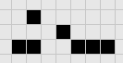

**DESIGN**

1. We need an array. The problem asks us the construct a 22x80 world. Ill make my array in memory 2 tiles larger in each dimension to make sure that I do not run out of bounds when I check cells on the edges. When I display the array to the user, rows 0 and 23 as well as columns 0 and 81 will not be visible (ill loop from 1-22 and 1-80 for rows and columns respectively).
2. Initially array will be filled with ‘-‘ to indicate that all cells are dead. The user will not see this array.
3. There will be 2 options to generate the initial configuration of alive cells in the world: the user will have an option to let the computer randomly generate 200 live cells or the user will have an option to indicate which cells they want to make alive. I’ll make a menu for that.
4. So for the randomly generated world, I’ll make a simple function:

void continueAutomate(char generation[][COLUMNUMNS]){

int coutAlive;

srand(time(0));

for (int countAlive =0; countAlive < 200; countAlive++){

generation[rand()%22+1][rand()%80+1] = 2;

}

}

Please note that row 0 and 23 as well as columns 0-81 are excluded, so live cell will not be placed there. Those cells will be always dead.

1. For the manual generation of the world, the function will look like that:

void continueManual(int row, int column){

char nextMove;

bool cont=true;

while(cont==true){

do{

cout<<"Enter row index of an alive world(1-22): ";

}while(row<1||row>22);

do{

cout<<"Enter colum index of an alive world(1-80): ";

}while(column<1||column>80);

world[row][column]=2; CELL WILL BE ASSIGNED TO LIVE

cout<<"\nDo you want to mark another alive world?(y/n): ";

do{

cin>>nextMove;

}while(user wants to assign another cell to be alive);

if(nextMove=='n'||nextMove=='N')

cont=false;

}

}

1. Once the world is generated, we’ll ask the user if they want to go to the next generation.
2. If the answer is yes, we need a function to count live neighbors around each cell.

Rows go from 0 to 23.

Columns go from 0-81. We do not check cells in row 0 and 23, and column 0 and 81.

Cells in those 2 rows and 2 columns will be dead all the time. So when I will test cells at the edges, all 8 neighbors will be checked and 3 cells that are “out of bounds” will be counted as dead.

I am planning to look at the neighbors by rows.: row above, same row and row below.

On the following website: http://ptgmedia.pearsoncmg.com/images/0672320665/downloads/The%20Game%20of%20Life.html, I found useful diagram:

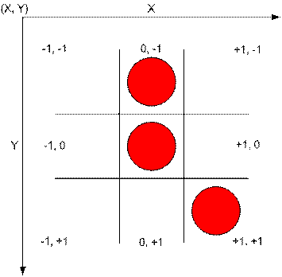

Lets say we are looking at the cell [0][0] and we want to check its neighbors above, so we’ll be looking at the row [0-1] (to generalize it is[idex-1] row). As for the column, we need to check column to the right and column to the left, so we are looking at (-1,-1) and (+1,-1) coordinates. (to generalize, the indexes of the columns are [column-1] and [column +1]. If there is a life in those cell, the cell will be counted as an alive neighbor.

//checking above row

if(((index_X-1)>=0)&&((index_Y-1)>=0)){ neighbors++;} TO THE LEFT

if(((index_Y-1)>=0)){neighbors++;}ABOVE

if(((index_Y-1)>=0)&&((index_X+1)<COLUMNUMNS){neighbors++;}TO THE RIGHT

Similar thing will be done for the row on which the cell is located and the row below.

I will assign live cell to char 2, which is displayed as smiley face.

1. After neighbors are counted, we need to determine which cells will die, which will stay alive and which will stay unchanged. There will be a function for this. The outcome will be stored in the temporary array to avoid changes in the original array before all counting is complete. So array is updated after we loop through the whole array.

if(neighbors>3 && generation[index_X][index_Y]==2){//overcrowding death

Replace live cell with dead : '-';

}

else if(neighbors<=1 &&generation[index_X][index_Y]==2){//dies from loneliness

Replace live cell with dead : '-';

}

else if(neighbors==3 &&generation[index_X][index_Y]=='-'){//birth if 3 neighbors

Replace live cell with alive cell : 2;

}

else

cell stays the same

1. Steps #8 and #9 needs to be done for every single cell in the array.

for(i=1;i<ROWS-1;i++){//WE WILL IGNORE ROW 0 AND 23 AS WELL AS COLUMNUMN 0 AND 81

for(j=1;j<COLUMNUMNS-1;j++){

count cell

determine what will happen in the next generation

}}

1. Once we are done looping through all cells, old world is replaced with the new world.
2. The user is asked if they want to move on to the next generation.
3. If the user decides to go to the next generation, above mentioned steps are repeated
4. If the answer is no, they program terminates with the thanks you message or something like that.

**TESTING**

|  |  |  |  |  |
| --- | --- | --- | --- | --- |
| Test | Case | Driver Function | Expected Output | Observed Output Or PASS/FALL |
| USER IS ASKED WHAT GAME THEY WANT TO CHOSE: MANUAL VS AUTAMATE VERSION | | | | |
| Enter value in the expected range: 1-3 | Enter # 1 | void MakeYourSelection() | User is asked to manualy enter alive cells | PASS |
| Enter value in the expected range: 1-3 | Enter # 2 | void MakeYourSelection() | Random world with 200 cells is generated | PASS |
| Enter value in the expected range: 1-3 | Enter #3 | MakeYourSelection() | Thanks you message for using the program | Pass |
| Enter letter or special character | Enter k or # | integerCheck(entered) | Error is displayed and user is asked to rake different entry | Pass |
| MANUAL METHOD TO PLAY A GAME | | | | |
| Enter number >3 | 5 | MakeYourSelection() | User is asked to reenter a number | Pass |
| Enter a number > 22 for row | 24 | continueManual(int row, int column) | User is asked to reenter a number | Pass |
| Enter a number that is < 1 for row | -2 | integerCheck(entered) | Error is displayed and user is asked to rake different entry | Pass |
| Enter a letter, string, etc | Kokodpos | integerCheck(entered) | Error is displayed and user is asked to rake different entry | Pass |
| Enter a number between 1 and 22 | 15 | continueManual(int row, int column) | Entry is accepted | Pass |
| Enter a number > 80 for column | 91 | continueManual(int row, int column) | User is asked to reenter a number | Pass |
| Enter a number that is < 1 for column | -3 | integerCheck(entered) | Error is displayed and user is asked to rake different entry | Pass |
| Enter a letter, string, etc | Kokodpos | integerCheck(entered) | Error is displayed and user is asked to rake different entry | Pass |
| Enter a number between 1 and 80 | 15 | continueManual(int row, int column) | Entry is accepted and user is asked if they want to choose one more cell | Pass |
|  |  |  |  |  |
| Answer Y or y to the question: Do you want to enter one more cell | Y or y | continueManual(int row, int column) | Lets the user enter row and column for another cell | Pass |
| Answer n or N to the question: Do you want to enter one more cell | N or n | Display(world,generation);  countueToNextGeneration(generation) | World is displayed and the user is asked if they want to move on to the next generation | Pass |
| Answer Y or y to the question: Do you to go to the next genereation | Y or y | Display(world,generation);  countueToNextGeneration(generation) | Taken to the next generation | Pass |
| Answer n or N to the question: Do you to go to the next genereation | N or n | countueToNextGeneration(generation)  goToMenuFunction(); | The user is asked if they want to go to the main menu to choose a different game | pass |
| Answer Y or y to the menu question | Y or y | goToMenuFunction(); | Taken to the menu to choose a different game | Pass |
| Answer N or n to the menu question | N or n | goToMenuFunction(); | Thanks you message and program ends | Pass |
| Enter something else to the question that requires Y or N | flkdjfls | goToMenuFunction();  or  continueManual(int row, int column) | Nothing will happen  The program will wait until y, n, Y or y  is enterd | pass |
| WORLD IS GENERATED BY THE COMPUTER | | | | |
| Every time a user decides to let the computer make the world, different armament of world is displayed | Try running automate world couple of time | continueAutomate(world); | Different worlds are generated | Pass |
| Tested the following arrangements of the alive cells to find out if you get the expected outcome :  You need to go to next generation x2  Tested stable positions; see below.  Checked that if the cell has less than 2 neighbors it dies.  Checked edges.  Look at the color coded table to determine how values you need to enter for rows and columns to do these tests. First value is row and second value is column.  ALL TESTS PASSED. | | | | |



STABLE POSITIONS:

|  |  |  |  |
| --- | --- | --- | --- |
| Square : http://www.math.cornell.edu/%7Elipa/mec/sq.png | Boat : http://www.math.cornell.edu/%7Elipa/mec/boat.png | Loaf : http://www.math.cornell.edu/%7Elipa/mec/loaf.png | Ship : http://www.math.cornell.edu/%7Elipa/mec/ship.png |

The following table is color coded. I’ll assign the following position to alive to find out if the expected outcome is achieved in the next generation. The expected outcomes shown above.

|  |  |  |  |  |  |  |  |  |  |  |  |  |  |  |  |  |  |  |  |  |
| --- | --- | --- | --- | --- | --- | --- | --- | --- | --- | --- | --- | --- | --- | --- | --- | --- | --- | --- | --- | --- |
| 1,1 | 1,2 | 1,3 | 1,4 | 1,5 | 1,6 | 1,7 | 1,8 | 1,9 | 1,10 | 1,11 | 1,12 | 1,13 | 1,14 | 1,15 | 1,16 | …… | 1,77 | 1,78 | 1,79 | 1,80 |
| 2,1 | 2,2 | 2,3 | 2,4 | 2,5 | 2,6 | 2,7 | 2,8 | 2,9 | 2,10 | 2,11 | 2,12 | 2,13 | 2,14 | 2,15 | 2,16 | …… | 2,77 | 2,78 | 2,79 | 2,80 |
| 3,1 | 3,2 | 3,3 | 3,4 | 3,5 | 3,6 | 3,7 | 3,8 | 3,9 | 3,10 | 3,11 | 3,12 | 3,13 | 3,14 | 3,15 | 3,16 | …… | 3,77 | 3,78 | 3,79 | 3,80 |
| 4,1 | 4,2 | 4,3 | 4,4 | 4,5 | 4,6 | 4,7 | 4,8 | 4,9 | 4,10 | 4,11 | 4,12 | 4,13 | 4,14 | 4,15 | 4,16 | …… | 4,77 | 4,78 | 4,79 | 4,80 |
| 5,1 | 5,2 | 5,3 | 5,4 | 5,5 | 5,6 | 5,7 | 5,8 | 5,9 | 5,10 | 5,11 | 5,12 | 5,13 | 5,14 | 5,15 | 5,16 | …… | 5,77 | 5,78 | 5,79 | 5,80 |
| 6,1 | 6,2 | 6,3 | 6,4 | 6,5 | 6,6 | 6,7 | 6,8 | 6,9 | 6,10 | 6,11 | 6,12 | 6,13 | 6,14 | 6,15 | 6,16 | …… | 6,77 | 6,78 | 6,79 | 6,80 |
| 7,1 | 7,2 | 7,3 | 7,4 | 7,5 | 7,6 | 7,7 | 7,8 | 7,9 | 7,10 | 7,11 | 7,12 | 7,13 | 7,14 | 7,15 | 7,16 | …… | 7,77 | 7,78 | 7,79 | 7,80 |
| 8,1 | 8,2 | 8,3 | 8,4 | 8,5 | 8,6 | 8,7 | 8,8 | 8,9 | 8,10 | 8,11 | 8,12 | 8,13 | 8,14 | 8,15 | 8,16 | …… | 8,77 | 8,78 | 8,79 | 8,80 |
| 9,1 | 9,2 | 9,3 | 9,4 | 9,5 | 9,6 | 9,7 | 9,8 | 9,9 | 9,10 | 9,11 | 9,12 | 9,13 | 9,14 | 9,15 | 9,16 | …… | 9,77 | 9,78 | 9,79 | 9,80 |
| 10,1 | 10,2 | 10,3 | 10,4 | 10,5 | 10,6 | 10,7 | 10,8 | 10,9 | 10,10 | 10,11 | 10,12 | 10,13 | 10,14 | 10,15 | 10,16 | …… | 10,77 | 10,78 | 10,79 | 10,80 |
| 11,1 | 11,2 | 11,3 | 11,4 | 11,5 | 11,6 | 11,7 | 11,8 | 11,9 | 11,10 | 11,11 | 11,12 | 11,13 | 11,14 | 11,15 | 11,16 | …… | 11,77 | 11,78 | 11,79 | 11,80 |
| ….. | ….. | ….. | ….. | ….. | ….. | ….. | ….. | ….. | ….. | ….. | ….. | ….. | ….. | ….. | ….. | …… | ….. | ….. | ….. | ….. |
| 18,1 | 18,2 | 18,3 | 18,4 | 18,5 | 18,6 | 18,7 | 18,8 | 18,9 | 18,10 | 18,11 | 18  ,12 | 18,13 | 18,14 | 18,15 | 18,16 | …… | 18,18 | 18,19 | 18,20 | 18,21 |
| 19,1 | 19,2 | 19,3 | 19,4 | 19,5 | 19,6 | 19,7 | 19,8 | 19,9 | 19,10 | 19,11 | 19,  12 | 19,  13 | 19,14 | 19,15 | 19,16 | …… | 19,77 | 19,78 | 19,79 | 19,80 |
| 20,1 | 20,2 | 20,3 | 20,4 | 20,5 | 20,6 | 20,7 | 20,8 | 20,9 | 20,10 | 20,11 | 20,  12 | 20,13 | 20,14 | 20,15 | 20,16 | …… | 20,77 | 20,78 | 20,79 | 20,80 |
| 21,1 | 21,2 | 21,3 | 21,4 | 21,5 | 21,6 | 21,7 | 21,8 | 21,9 | 21,10 | 21,11 | 21,12 | 21,13 | 21,14 | 21,15 | 21,16 | …… | 21,77 | 21,78 | 21,79 | 21,80 |
| 22,1 | 22,2 | 22,3 | 22,4 | 22,5 | 22,6 | 22,7 | 22,8 | 22,9 | 22,10 | 22,11 | 22,12 | 22,13 | 22,14 | 22,15 | 22,16 | …… | 22,77 | 22,80 | 22,79 | 22,80 |

|  |  |  |  |  |  |  |  |  |  |  |  |  |  |  |  |  |  |  |  |  |
| --- | --- | --- | --- | --- | --- | --- | --- | --- | --- | --- | --- | --- | --- | --- | --- | --- | --- | --- | --- | --- |
| 1,1 | 1,2 | 1,3 | 1,4 | 1,5 | 1,6 | 1,7 | 1,8 | 1,9 | 1,10 | 1,11 | 1,12 | 1,13 | 1,14 | 1,15 | 1,16 | …… | 1,77 | 1,78 | 1,79 | 1,80 |
| 2,1 | 2,2 | 2,3 | 2,4 | 2,5 | 2,6 | 2,7 | 2,8 | 2,9 | 2,10 | 2,11 | 2,12 | 2,13 | 2,14 | 2,15 | 2,16 | …… | 2,77 | 2,78 | 2,79 | 2,80 |
| 3,1 | 3,2 | 3,3 | 3,4 | 3,5 | 3,6 | 3,7 | 3,8 | 3,9 | 3,10 | 3,11 | 3,12 | 3,13 | 3,14 | 3,15 | 3,16 | …… | 3,77 | 3,78 | 3,79 | 3,80 |
| 4,1 | 4,2 | 4,3 | 4,4 | 4,5 | 4,6 | 4,7 | 4,8 | 4,9 | 4,10 | 4,11 | 4,12 | 4,13 | 4,14 | 4,15 | 4,16 | …… | 4,77 | 4,78 | 4,79 | 4,80 |
| 5,1 | 5,2 | 5,3 | 5,4 | 5,5 | 5,6 | 5,7 | 5,8 | 5,9 | 5,10 | 5,11 | 5,12 | 5,13 | 5,14 | 5,15 | 5,16 | …… | 5,77 | 5,78 | 5,79 | 5,80 |
| 6,1 | 6,2 | 6,3 | 6,4 | 6,5 | 6,6 | 6,7 | 6,8 | 6,9 | 6,10 | 6,11 | 6,12 | 6,13 | 6,14 | 6,15 | 6,16 | …… | 6,77 | 6,78 | 6,79 | 6,80 |
| 7,1 | 7,2 | 7,3 | 7,4 | 7,5 | 7,6 | 7,7 | 7,8 | 7,9 | 7,10 | 7,11 | 7,12 | 7,13 | 7,14 | 7,15 | 7,16 | …… | 7,77 | 7,78 | 7,79 | 7,80 |
| 8,1 | 8,2 | 8,3 | 8,4 | 8,5 | 8,6 | 8,7 | 8,8 | 8,9 | 8,10 | 8,11 | 8,12 | 8,13 | 8,14 | 8,15 | 8,16 | …… | 8,77 | 8,78 | 8,79 | 8,80 |
| 9,1 | 9,2 | 9,3 | 9,4 | 9,5 | 9,6 | 9,7 | 9,8 | 9,9 | 9,10 | 9,11 | 9,12 | 9,13 | 9,14 | 9,15 | 9,16 | …… | 9,77 | 9,78 | 9,79 | 9,80 |
| 10,1 | 10,2 | 10,3 | 10,4 | 10,5 | 10,6 | 10,7 | 10,8 | 10,9 | 10,10 | 10,11 | 10,12 | 10,13 | 10,14 | 10,15 | 10,16 | …… | 10,77 | 10,78 | 10,79 | 10,80 |
| 11,1 | 11,2 | 11,3 | 11,4 | 11,5 | 11,6 | 11,7 | 11,8 | 11,9 | 11,10 | 11,11 | 11,12 | 11,13 | 11,14 | 11,15 | 11,16 | …… | 11,77 | 11,78 | 11,79 | 11,80 |
| ….. | ….. | ….. | ….. | ….. | ….. | ….. | ….. | ….. | ….. | ….. | ….. | ….. | ….. | ….. | ….. | …… | ….. | ….. | ….. | ….. |
| 18,1 | 18,2 | 18,3 | 18,4 | 18,5 | 18,6 | 18,7 | 18,8 | 18,9 | 18,10 | 18,11 | 18  ,12 | 18,13 | 18,14 | 18,15 | 18,16 | …… | 18,18 | 18,19 | 18,20 | 18,21 |
| 19,1 | 19,2 | 19,3 | 19,4 | 19,5 | 19,6 | 19,7 | 19,8 | 19,9 | 19,10 | 19,11 | 19,  12 | 19,  13 | 19,14 | 19,15 | 19,16 | …… | 19,77 | 19,78 | 19,79 | 19,80 |
| 20,1 | 20,2 | 20,3 | 20,4 | 20,5 | 20,6 | 20,7 | 20,8 | 20,9 | 20,10 | 20,11 | 20,  12 | 20,13 | 20,14 | 20,15 | 20,16 | …… | 20,77 | 20,78 | 20,79 | 20,80 |
| 21,1 | 21,2 | 21,3 | 21,4 | 21,5 | 21,6 | 21,7 | 21,8 | 21,9 | 21,10 | 21,11 | 21,12 | 21,13 | 21,14 | 21,15 | 21,16 | …… | 21,77 | 21,78 | 21,79 | 21,80 |
| 22,1 | 22,2 | 22,3 | 22,4 | 22,5 | 22,6 | 22,7 | 22,8 | 22,9 | 22,10 | 22,11 | 22,12 | 22,13 | 22,14 | 22,15 | 22,16 | …… | 22,77 | 22,80 | 22,79 | 22,80 |

Expected outcome:

|  |  |  |  |  |  |  |  |  |  |  |  |  |  |  |  |  |  |  |  |  |
| --- | --- | --- | --- | --- | --- | --- | --- | --- | --- | --- | --- | --- | --- | --- | --- | --- | --- | --- | --- | --- |
| 1,1 | 1,2 | 1,3 | 1,4 | 1,5 | 1,6 | 1,7 | 1,8 | 1,9 | 1,10 | 1,11 | 1,12 | 1,13 | 1,14 | 1,15 | 1,16 | …… | 1,77 | 1,78 | 1,79 | 1,80 |
| 2,1 | 2,2 | 2,3 | 2,4 | 2,5 | 2,6 | 2,7 | 2,8 | 2,9 | 2,10 | 2,11 | 2,12 | 2,13 | 2,14 | 2,15 | 2,16 | …… | 2,77 | 2,78 | 2,79 | 2,80 |
| 3,1 | 3,2 | 3,3 | 3,4 | 3,5 | 3,6 | 3,7 | 3,8 | 3,9 | 3,10 | 3,11 | 3,12 | 3,13 | 3,14 | 3,15 | 3,16 | …… | 3,77 | 3,78 | 3,79 | 3,80 |
| 4,1 | 4,2 | 4,3 | 4,4 | 4,5 | 4,6 | 4,7 | 4,8 | 4,9 | 4,10 | 4,11 | 4,12 | 4,13 | 4,14 | 4,15 | 4,16 | …… | 4,77 | 4,78 | 4,79 | 4,80 |
| 5,1 | 5,2 | 5,3 | 5,4 | 5,5 | 5,6 | 5,7 | 5,8 | 5,9 | 5,10 | 5,11 | 5,12 | 5,13 | 5,14 | 5,15 | 5,16 | …… | 5,77 | 5,78 | 5,79 | 5,80 |
| 6,1 | 6,2 | 6,3 | 6,4 | 6,5 | 6,6 | 6,7 | 6,8 | 6,9 | 6,10 | 6,11 | 6,12 | 6,13 | 6,14 | 6,15 | 6,16 | …… | 6,77 | 6,78 | 6,79 | 6,80 |
| 7,1 | 7,2 | 7,3 | 7,4 | 7,5 | 7,6 | 7,7 | 7,8 | 7,9 | 7,10 | 7,11 | 7,12 | 7,13 | 7,14 | 7,15 | 7,16 | …… | 7,77 | 7,78 | 7,79 | 7,80 |
| 8,1 | 8,2 | 8,3 | 8,4 | 8,5 | 8,6 | 8,7 | 8,8 | 8,9 | 8,10 | 8,11 | 8,12 | 8,13 | 8,14 | 8,15 | 8,16 | …… | 8,77 | 8,78 | 8,79 | 8,80 |
| 9,1 | 9,2 | 9,3 | 9,4 | 9,5 | 9,6 | 9,7 | 9,8 | 9,9 | 9,10 | 9,11 | 9,12 | 9,13 | 9,14 | 9,15 | 9,16 | …… | 9,77 | 9,78 | 9,79 | 9,80 |
| 10,1 | 10,2 | 10,3 | 10,4 | 10,5 | 10,6 | 10,7 | 10,8 | 10,9 | 10,10 | 10,11 | 10,12 | 10,13 | 10,14 | 10,15 | 10,16 | …… | 10,77 | 10,78 | 10,79 | 10,80 |
| 11,1 | 11,2 | 11,3 | 11,4 | 11,5 | 11,6 | 11,7 | 11,8 | 11,9 | 11,10 | 11,11 | 11,12 | 11,13 | 11,14 | 11,15 | 11,16 | …… | 11,77 | 11,78 | 11,79 | 11,80 |
| ….. | ….. | ….. | ….. | ….. | ….. | ….. | ….. | ….. | ….. | ….. | ….. | ….. | ….. | ….. | ….. | …… | ….. | ….. | ….. | ….. |
| 18,1 | 18,2 | 18,3 | 18,4 | 18,5 | 18,6 | 18,7 | 18,8 | 18,9 | 18,10 | 18,11 | 18  ,12 | 18,13 | 18,14 | 18,15 | 18,16 | …… | 18,18 | 18,19 | 18,20 | 18,21 |
| 19,1 | 19,2 | 19,3 | 19,4 | 19,5 | 19,6 | 19,7 | 19,8 | 19,9 | 19,10 | 19,11 | 19,  12 | 19,  13 | 19,14 | 19,15 | 19,16 | …… | 19,77 | 19,78 | 19,79 | 19,80 |
| 20,1 | 20,2 | 20,3 | 20,4 | 20,5 | 20,6 | 20,7 | 20,8 | 20,9 | 20,10 | 20,11 | 20,  12 | 20,13 | 20,14 | 20,15 | 20,16 | …… | 20,77 | 20,78 | 20,79 | 20,80 |
| 21,1 | 21,2 | 21,3 | 21,4 | 21,5 | 21,6 | 21,7 | 21,8 | 21,9 | 21,10 | 21,11 | 21,12 | 21,13 | 21,14 | 21,15 | 21,16 | …… | 21,77 | 21,78 | 21,79 | 21,80 |
| 22,1 | 22,2 | 22,3 | 22,4 | 22,5 | 22,6 | 22,7 | 22,8 | 22,9 | 22,10 | 22,11 | 22,12 | 22,13 | 22,14 | 22,15 | 22,16 | …… | 22,77 | 22,80 | 22,79 | 22,80 |

**REFLECTION:**

It took me longer to design the program that expected. In the description of the program, professor mentions that this program will be easy to implement, I disagree. Maybe if you have PhD in CS its easy, but a person like I had to spent over 40 hours completing this assignment.

(sorry for venting)

My main problem was with counting of neighbors. Initially I was planning to use a some something like this:

//checking above row

if(((index_X-1)>=0)&&((index_Y-1)>=0)){ neighbors++;} TO THE LEFT

if(((index_Y-1)>=0)){neighbors++;}ABOVE

if(((index_Y-1)>=0)&&((index_X+1)<COLUMNUMNS){neighbors++;}TO THE RIGHT

However, the function was not working, so I had to change it to:

if(((index_X-1)>=0)&&((index_Y-1)>=0)&&(generation[index_X-1][index_Y-1]==2)){ neighbors++;}

if(((index_X-1)>=0)&&(generation[index_X-1][index_Y]==2)){neighbors++;}

if(((index_X-1)>=0)&&((index_Y+1)<COLUMNS)&&(generation[index_X-1][index_Y+1]==2)){neighbors++;}

Basically, we need to check and make sure that cell is alive and only then count neighbors.

Another problem that I;ve encountered was, the menu function.

When the user was done playing game and was asked if they want to play one more time, the entry was accepted, but nothing was done. This was because my initial switch statement was:

void MakeYourSelection(){

string entered;

int input;

int row, column;

cout << "Make your selection: ";

getline(cin,entered);// >> input;

input = integerCheck(entered);

switch(input)

{

case 1:

continueManual(row, column);

break;

case 2:

continueAutomate(world);

break;

case 3:

cout << "Have a nice day.\n";

break;

default:

cout << "Error, please pick 1, 2, or 3." << endl;

MakeYourSelection();

break;

}

}

And main method was:

int main(){

bool cont=true;

// bool cont=true;

int generation =0;

initializeToMinusSign(world);

Introduction();

MakeYourSelection();

cont=true;

Display(world,generation);

countueToNextGeneration(generation);

goToMenuFunction();

return 0;

}

So if the user wanted to play the game second time, the program was taking the user to the

continueAutomate(world); or continueManual(row, column); depending on the selection, but nothing was done because no other functions were called after that. I had to change my switch statement and main function to:

switch(input)

{

case 1:

initializeToMinusSign(world);

continueManual(row, column);

Display(world,generation);

countueToNextGeneration(generation);

goToMenuFunction();

break;

case 2:

initializeToMinusSign(world);

continueAutomate(world);

Display(world,generation);

countueToNextGeneration(generation);

goToMenuFunction();

break;

case 3:

cout << "Have a nice day.\n";

break;

default:

cout << "Error, please pick 1, 2, or 3." << endl;

MakeYourSelection();

break;

}

}

And

int main(){

bool cont=true;

Introduction();

MakeYourSelection();

return 0;

}

And the program works as expected.

I found this assignment very valuable; because I had a hard time with 2D array, but it seems that maybe i finally understand them.

Finally, after I wrote the program, I decided to put everything in a class. I rearranged the whole program, it was working fine, but then I decided to do some more optimization and of course I have not backed my program. After “optimization” the program had so many bugs, I spent over 4 hours fixing it, gave up and decided not to mess with classes any more. The take-home message, next time Ill save a program in at least 3 different holders before I start “optimizing” it.

I did use some references while writing this program. Links are provided in the design and in the comments of the program.

So I just tried to run the program on the flip, it compiled, but for some reason not the whole row 22 is displayed as a result of this my program does not work, the way it is expected to work. I do not know whats going on. It work fine on my computer, but it works completely different on the flip.

On my computer, it looks like this:

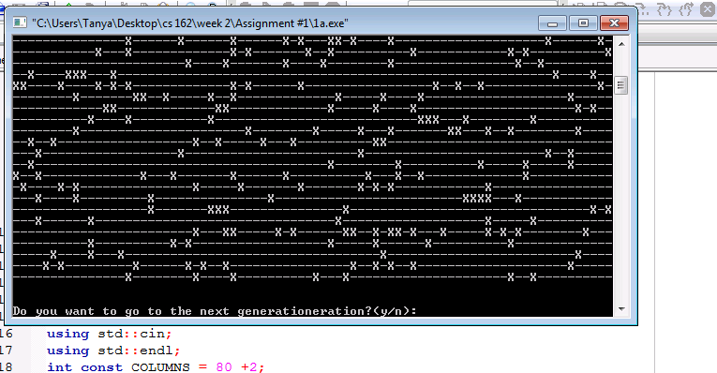

On flip, it looks like this:

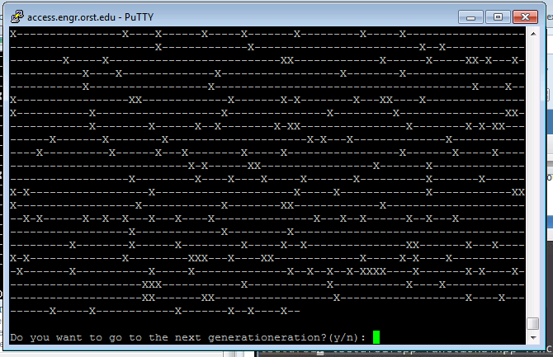

I do not know whats going on, but my program does not behave the way its expected.

It took me a while to figure out what was going on.

The problem is that I was not starting new row from new line. Display function was modified:

void Display(const char generation[][COLUMNS],int generationCount){

cout<<"\n\n\n Generationeration "<<generationCount<<":\n\n";

for(int i=1;i<ROWS-1;i++){

for(int j=1;j<COLUMNS-1;j++){

cout<<generation[i][j];

}

cout<<endl;// THIS WAS MISSING. ELEMENTS WHERE POPULATING THE SCREEN UNTIL THERE WAS NO MORE SPACE ON THE SCREEN. ONCE I ADDED THIS, THE PROBLEM IS FIXED.

}

}

However, I tried to change columns to 90 and look what I got:

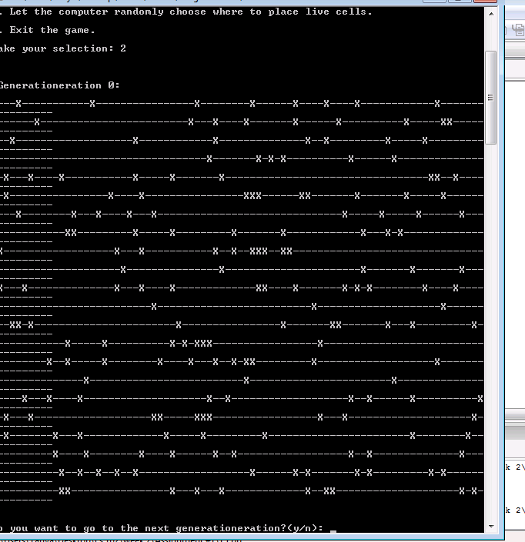

Now it made sense what when professor was talking about the screen..

Anyways, if on your computer, my program shows similar behavior, just change columns # to 60 or something like that, it will work as expected.